CHINESE FLAGSHIP SECONDARY CURRICULUM
Level 1, Unit 4: At School
Assessment: Interpersonal and Presentational Writing

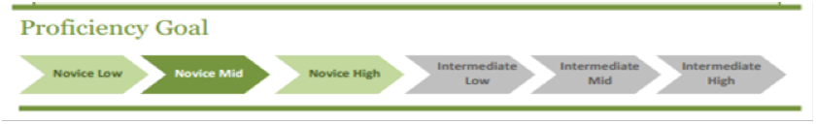

Scenario 1 | Objectives
Scenario 1:  It’s the day before the winter break and the school had a holiday assembly for the entire afternoon. You are one of the students who helped organize the assembly and you found a book bag left at the auditorium with no name on it.  - Describe the book bag with color and list the items in the book bag with details.  - Leave your name and phone number for contacts. | - I can list school supply items with details, including number and colors.  - I can describe an item with details.

Assessment: Interpersonal & Presentational Speaking

Scenario 2 | Objectives
Scenario 2:  - You are writing an email to your pen pal in your sister school in China at the beginning of the school year. You would like to share about shopping for school supplies for the new school year and you are wondering whether students in China have similar experiences.  - Greet your Chinese pen pal with proper language and in a friendly manner.  - Talk about the supplies that you plan to buy.  - Ask your pen pal what supplies they plan to buy for school.  - Say farewell | - I can write an email in a proper format to a Chinese peer.  - I can list school supply items that I prepare for school.  - I can ask what school supplies someone is going to buy.

Adapted from Jefferson County Public Schools, KY, 2011

